



**UNIVERSITY OF ENERGY AND NATURAL RESOURCES**

**DEPARTMENT OF INFORMATION TECHNOLOGY AND DECISION SCIENCES**

**PROJECT NAME:**

**EMPLOYEE PAYROLL SYSTEM**

**AUTHOR: GROUP 6**

**DATE: 31ST MARCH 2025**

**TABLE OF CONTENTS**

**1. INTRODUCTION**

* Background
* Purpose
* Scope
* Target Users
* System Benefits

**2. SYSTEM OVERVIEW**

* + Core Modules
  + System Architecture
  + User Interface

**3. FUNCTIONAL REQUIREMENTS**

* Employee Management
* Earnings & Deductions
* Claim Entry
* Loan Management
* Attendance & Leave Management
* Pay Generation
* Reporting & Analytics

**4. TECHNICAL SPECIFICATIONS**

* + Database Design
  + System Requirements
  + Security Features
  + Integration Capabilities
  + Data Backup & Recovery

**5. USE CASES**

* + Employee Onboarding
  + Payroll Processing
  + Pay Slip Generation
  + Claim and Loan Management
  + Attendance Management

**6. METHODOLOGY**

* + System Development Approach
  + Technologies Used
  + Testing Strategy
  + Implementation Plan

**7. USER GUIDES**

* + Administrator Guide
  + HR Manager Guide
  + Employee Guide

**8. APPENDICES**

* + Glossary
  + FAQ
  + Support Contacts

**1. INTRODUCTION**

**Background**

Payroll management is a fundamental process for any organization, ensuring employees are compensated accurately and on time while maintaining compliance with tax and labor laws. A payroll system facilitates this by automating tasks such as calculating employee wages, managing deductions, and generating reports. Traditionally, payroll was managed manually, but the increasing complexity of modern workplaces and regulations has made automated systems indispensable. These systems not only reduce errors but also save time and resources, making them essential for businesses of all sizes.

**Purpose**

The purpose of this proposal is to develop a robust Employee Payroll System that streamlines payroll operations, enhances accuracy, and ensures compliance with organizational policies and government regulations. The system will automate critical processes such as pay generation, attendance tracking, claim management, and reporting, thereby reducing administrative burdens and improving operational efficiency.

**Scope**

This payroll system will be designed to handle the following:

* + Employee management, including salary structures and benefits.
  + Attendance tracking integrated with timekeeping systems.
  + Loan and claim management with approval workflows.
  + Automated pay generation with deductions for taxes and benefits.
  + Comprehensive reporting for payroll summaries, tax filings, and analytics.

The system will cater to the needs of HR managers, payroll administrators, and employees by providing role-specific functionalities through a user-friendly interface.

**Target Users**

* + HR Managers: To manage employee records, approve claims/loans, and oversee payroll operations.
  + Payroll Administrators: To process payroll, generate reports, and ensure compliance with tax laws.
  + Employees: To view payslips, submit claims/loans, and track attendance or leave requests.

**System Benefits**

* Efficiency: Automates repetitive tasks such as salary calculations and tax deductions.
* Accuracy: Reduces human errors in payroll processing through automated calculations.
* Compliance: Ensures adherence to local tax laws and labor regulations by integrating updates automatically into the system.
* Customization: Adapts to organizational policies for claims, loans, leaves, and benefits management.
* Transparency: Provides employees with access to detailed payslips and records of claims or deductions.

**2. SYSTEM OVERVIEW**

**Core Modules**

* The Employee Payroll System will consist of the following key modules:
* Employee Management: Centralized repository for employee information, including salary structures, benefits, and tax details.
* Attendance & Leave Management: Tracks employee attendance, work hours, and leave requests, integrating with biometric systems or manual inputs.
* Claim and Loan Management: Enables employees to submit claims and loan requests while providing an approval workflow for administrators.
* Pay Generation: Automates payroll calculations, including earnings, deductions, and tax compliance.
* Reporting & Analytics: Generates detailed reports on payroll summaries, attendance records, and more for decision-making.

**System Architecture**

The system will adopt a client-server architecture with the following components:

* Frontend: A web-based interface using technologies such as React.js or Angular for a responsive and user-friendly experience.
* Database: A relational database like MySQL to securely store employee and payroll data.

**User Interface**

The system will feature a clean and intuitive interface tailored to different user roles:

* Administrators: Access to manage employee records, approve claims/loans, and generate payroll reports.
* Employees: Self-service portal to view payslips, submit claims/loans, and track attendance or leave requests.

**Key Features of the System**

* Automation: Automates repetitive tasks such as salary computation, tax deductions, and benefits disbursement.
* Accuracy: Reduces manual errors through predefined workflows for payroll processing.
* Scalability: Designed to handle increasing employee data as the organization grows.
* Compliance: Ensures adherence to local labor laws and tax regulations through automated updates.

**Advantages Over Manual Systems**

* Saves time by automating payroll tasks that are traditionally labor-intensive.
* Enhances accuracy in calculations for salaries, taxes, and deductions.
* Provides real-time access to payroll data for both employees and administrators.

**Screenshot of the interface**

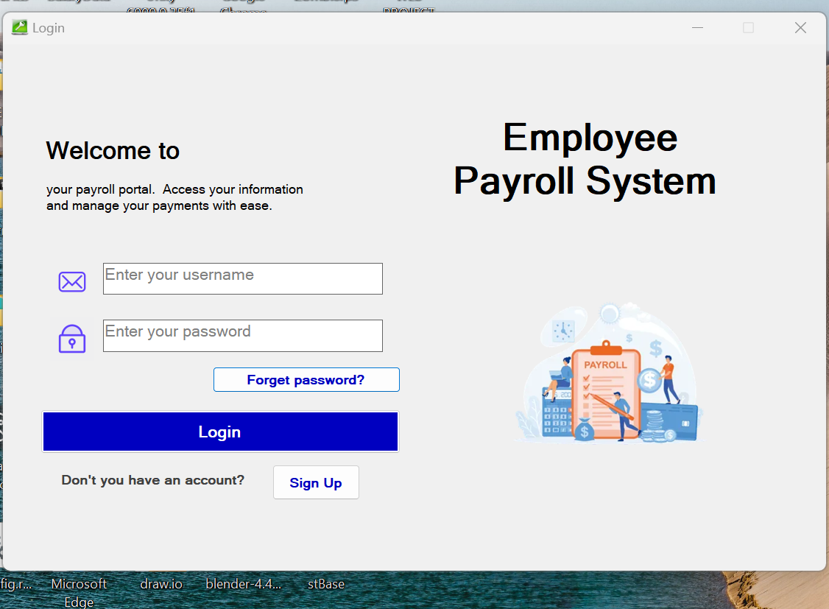

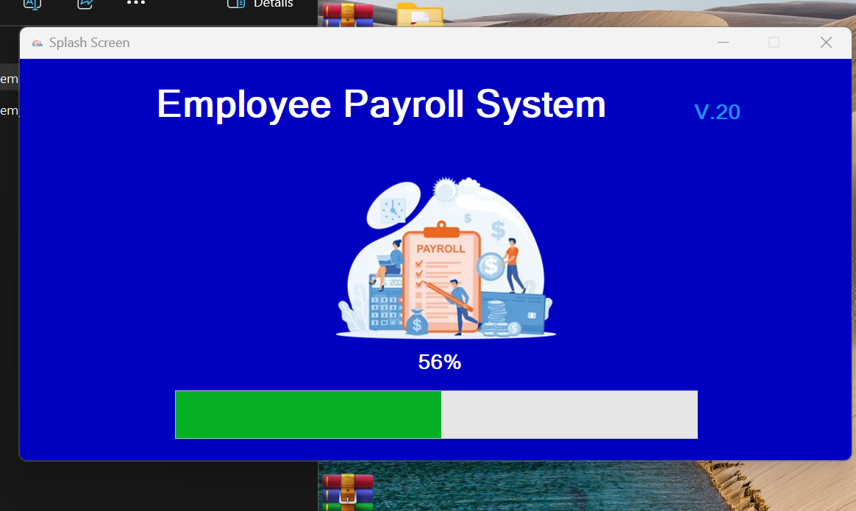

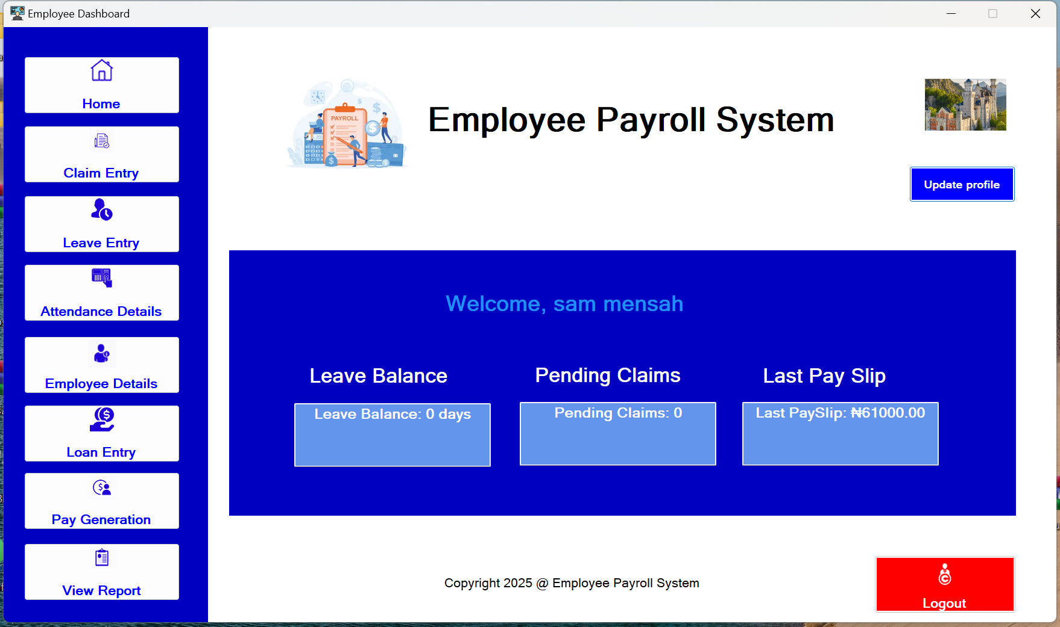

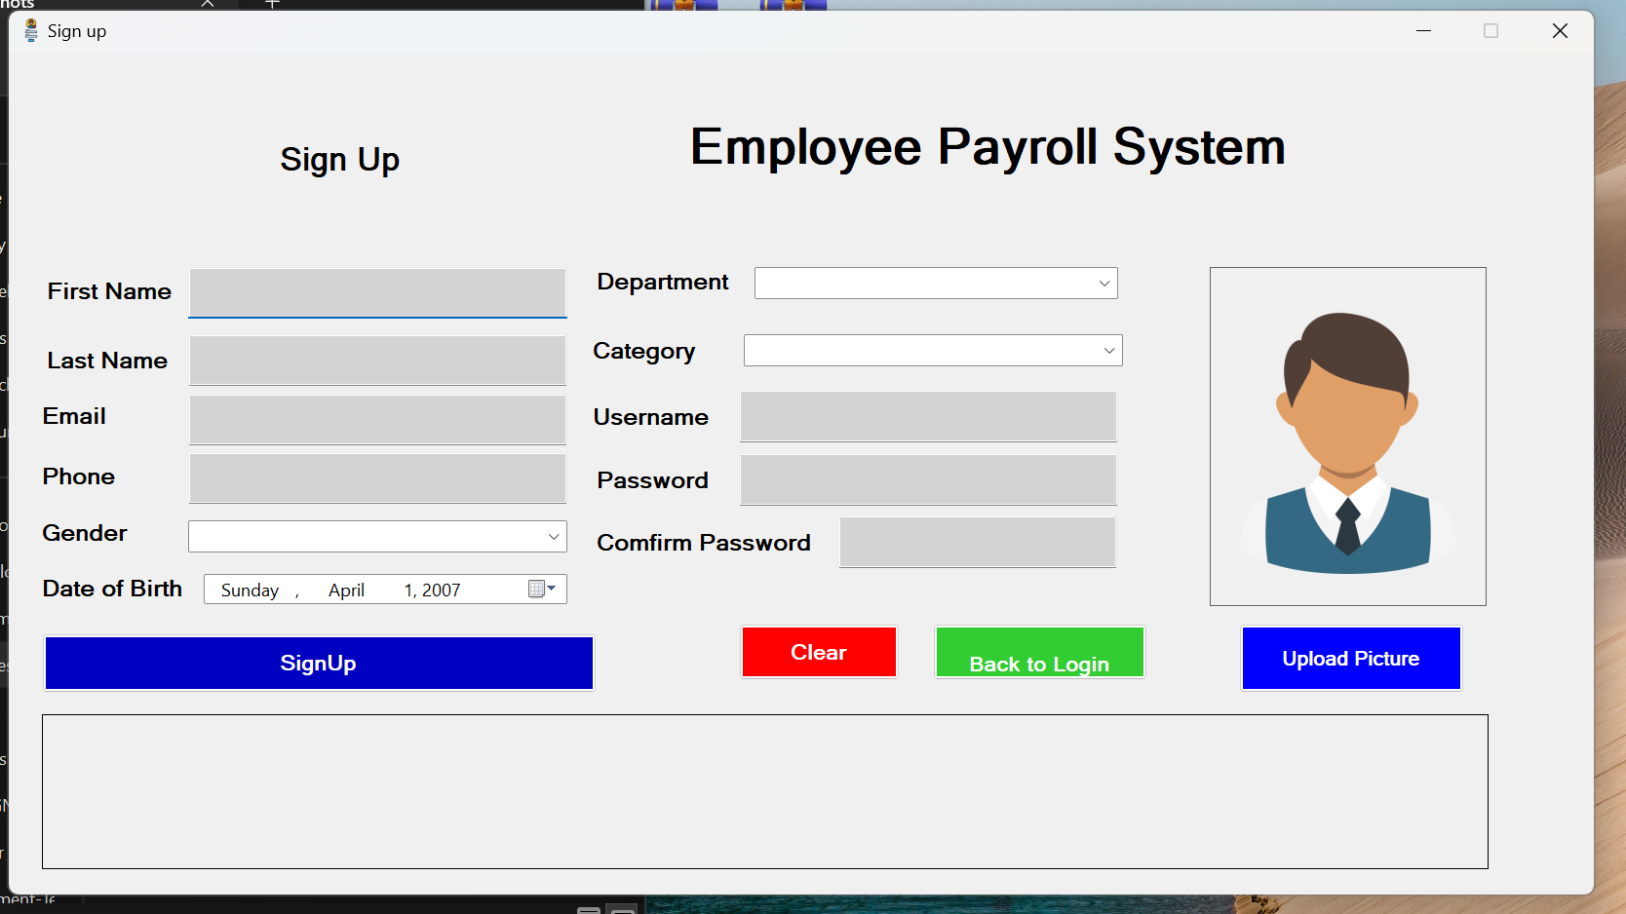

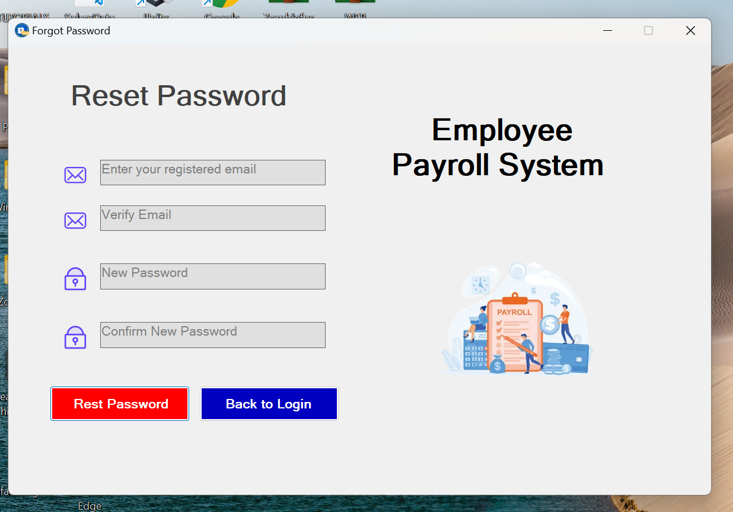

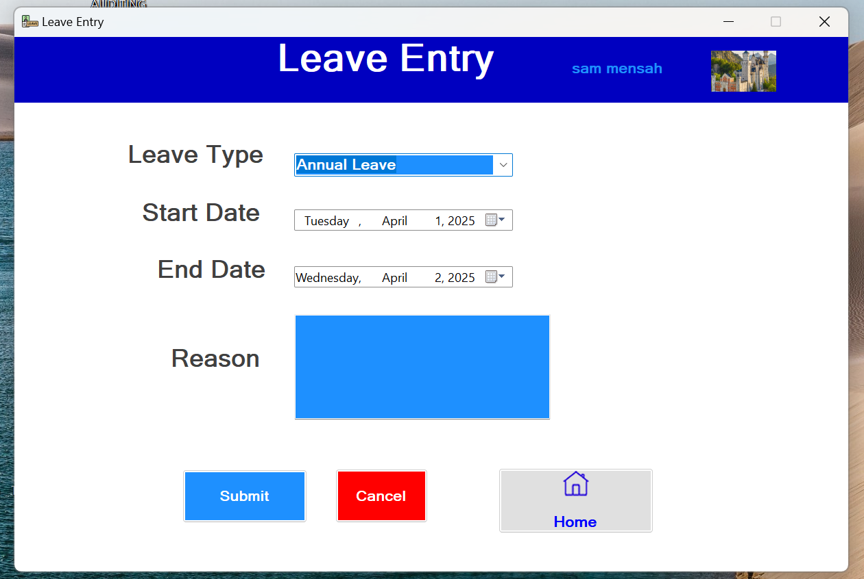

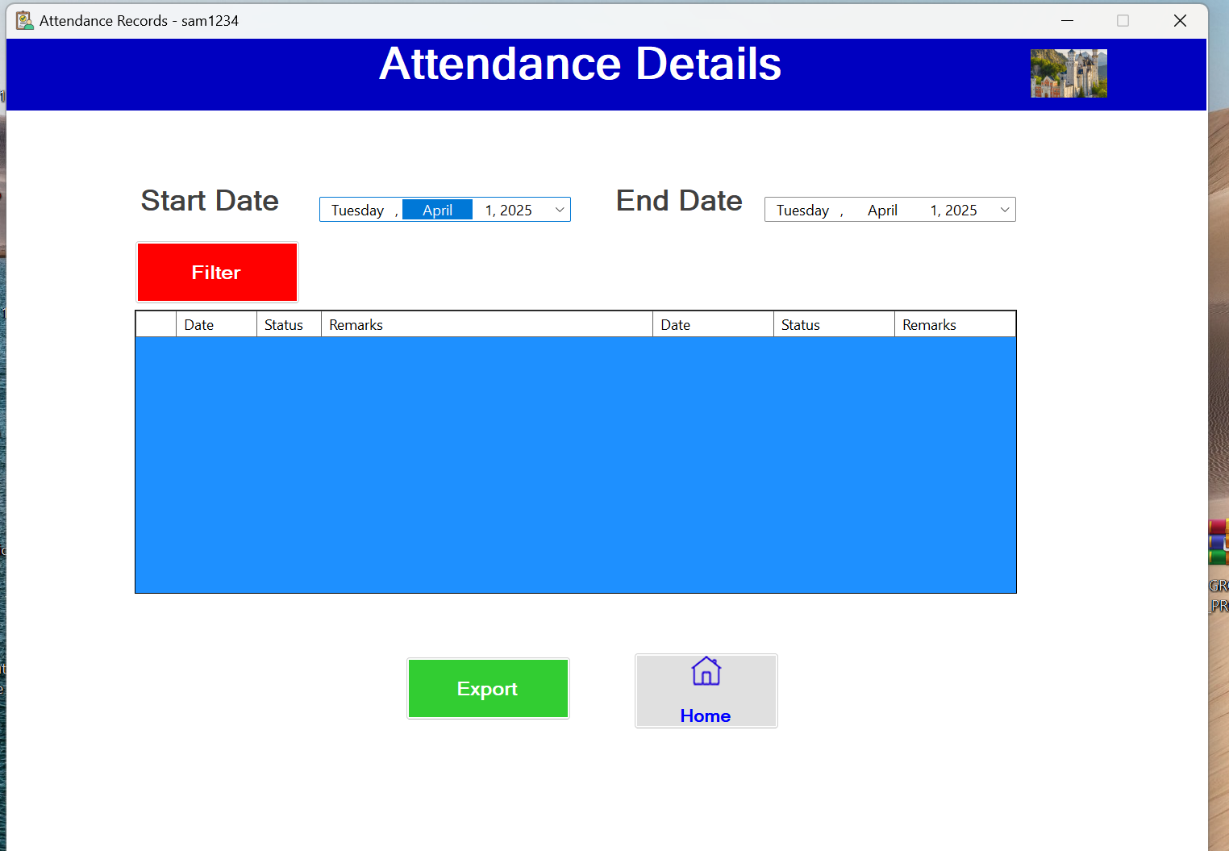

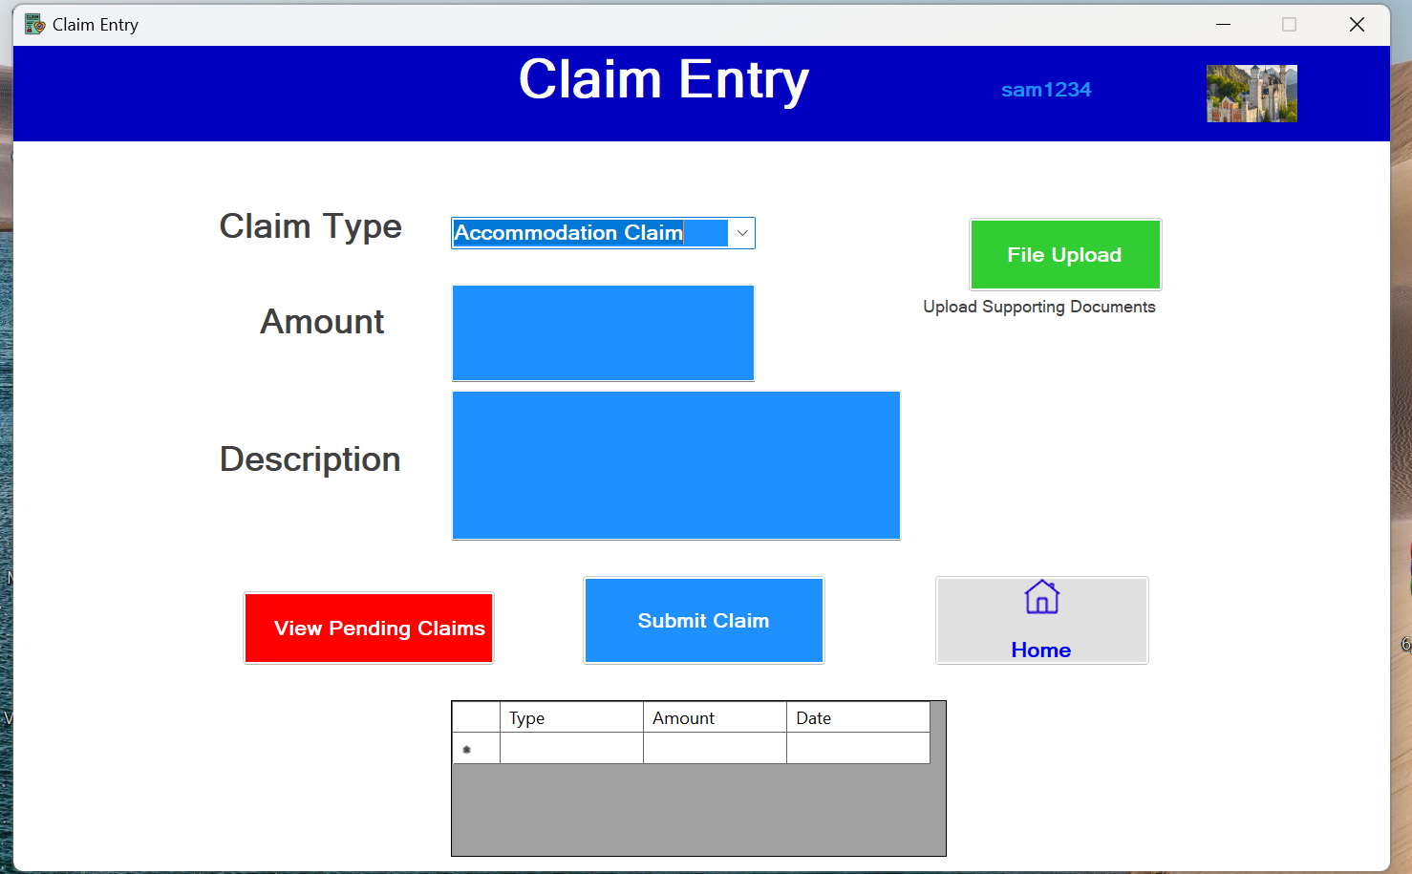

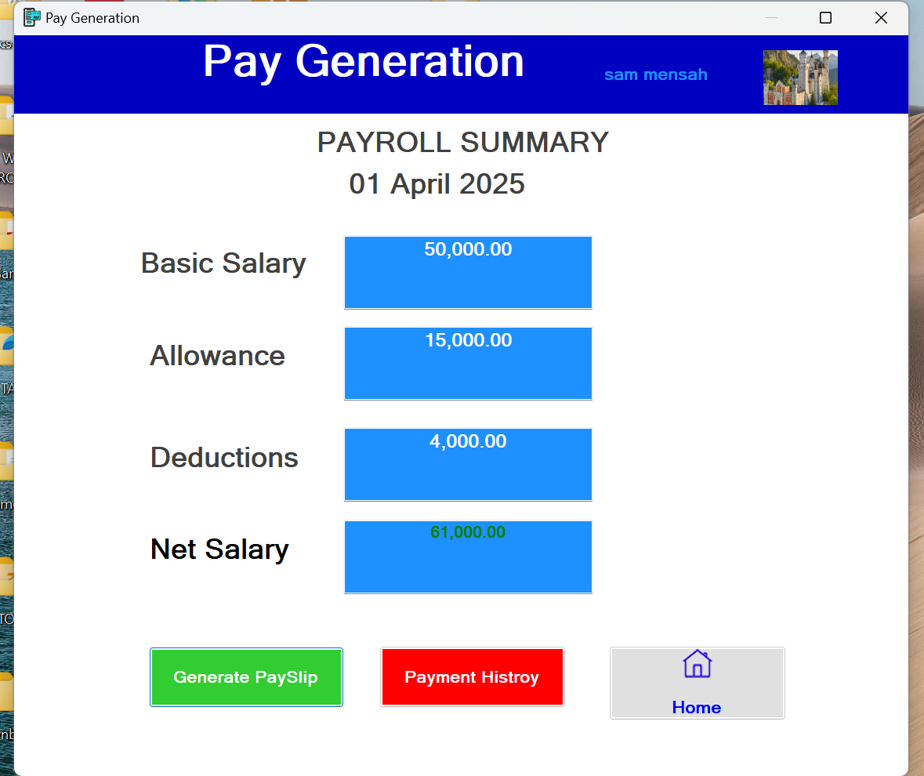

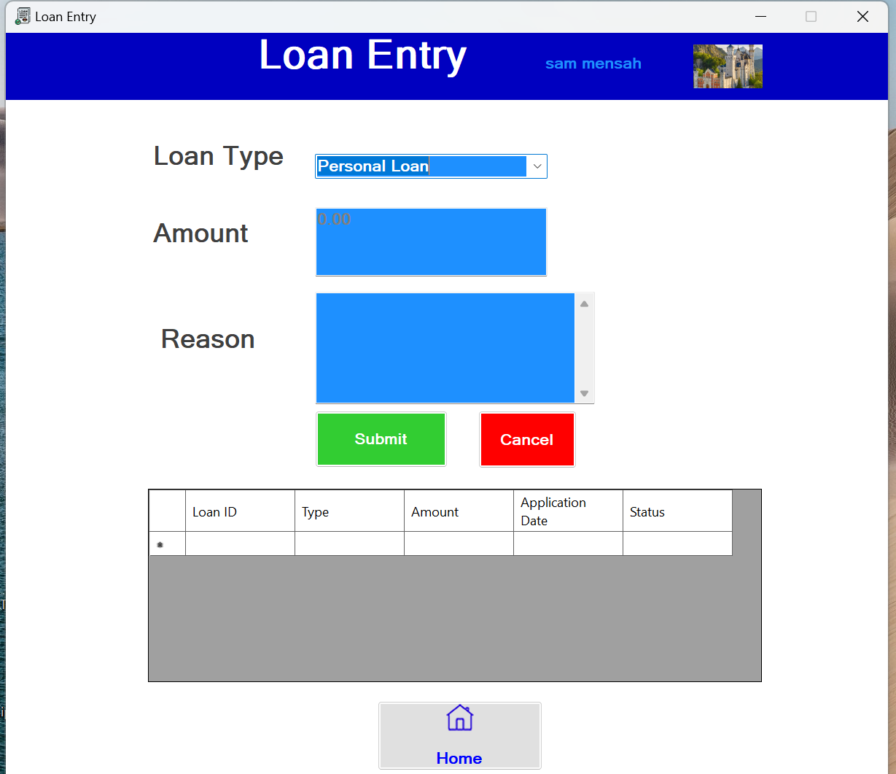

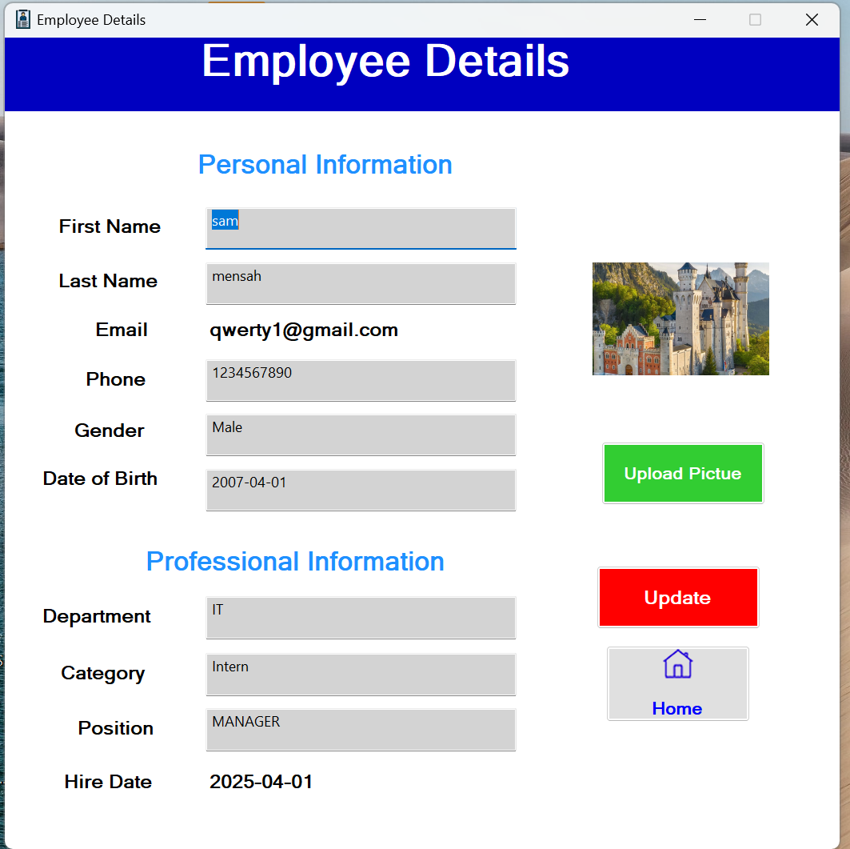

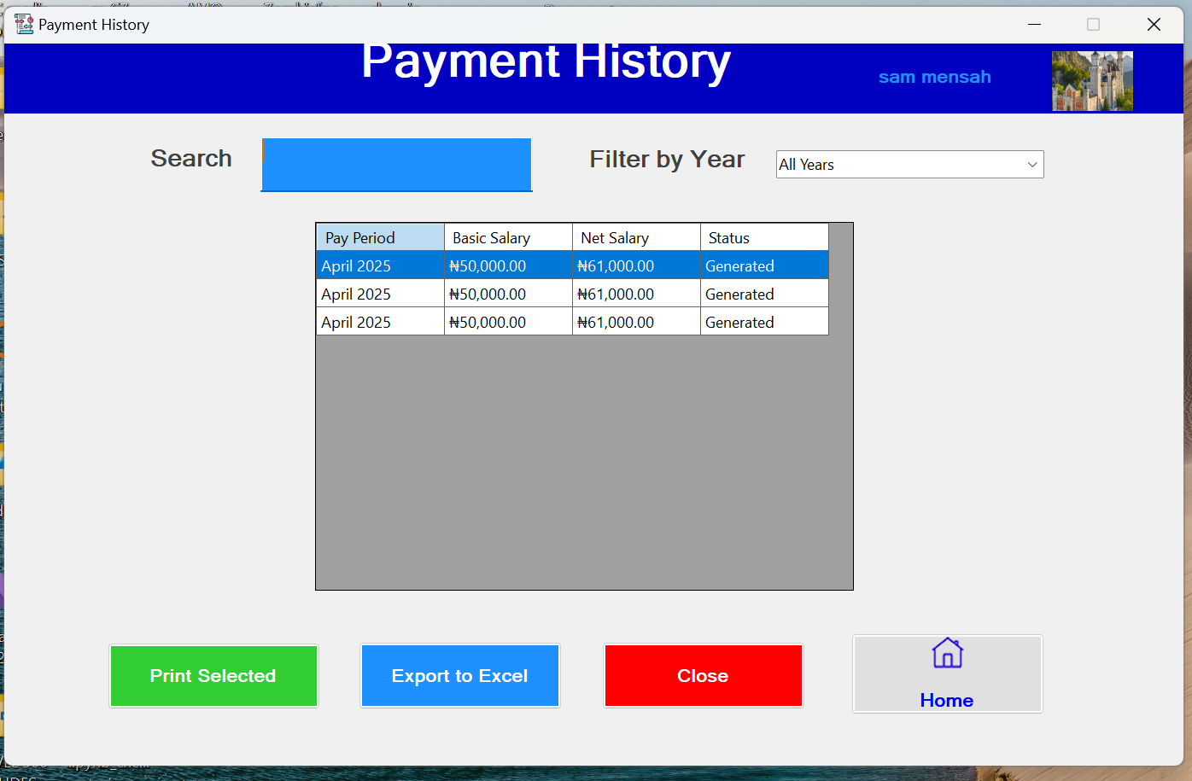

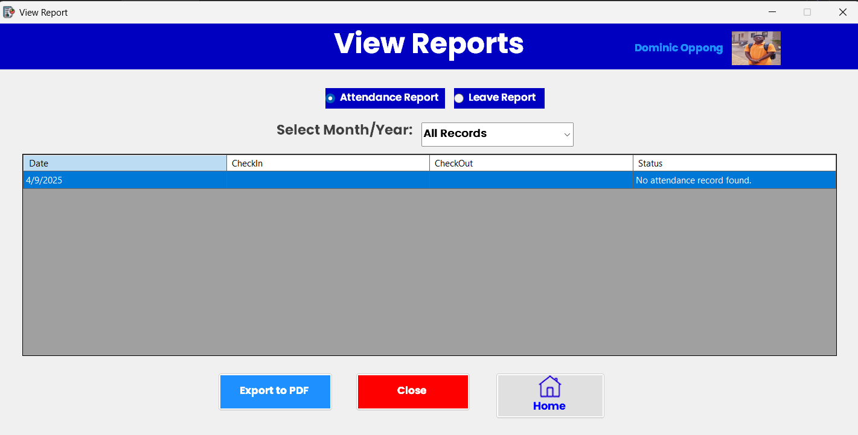

**3. FUNCTIONAL REQUIREMENTS**

**Employee Management**

* **Employee Profile Management:** Store detailed employee information, including personal details, salary structures, benefits, and tax details.
* **Role-Based Access Control:** Ensure that different roles (e.g., HR, Administrator, Employee) have appropriate access levels to manage and view employee data securely.
* **Employee Onboarding Process:** Automate the process of adding new employees to the system, including setting up payroll details and benefits.

**Earnings & Deductions**

* **Salary Calculation:** Automate gross pay calculations based on salary structures, overtime, bonuses, and other earnings.
* **Deductions Management:** Handle statutory deductions (e.g., taxes, pension contributions) and voluntary deductions (e.g., health insurance).
* **Benefits Administration:** Manage employee benefits such as health insurance, retirement plans, and paid time off.

**Claim Entry**

* **Claim Submission:** Allow employees to submit claims (e.g., expense reimbursements) through a user-friendly interface.
* **Approval Workflow:** Implement a workflow for approving claims, ensuring that managers can review and approve or reject claims efficiently.

**Loan Management**

* **Loan Application:** Provide a module for employees to apply for loans, specifying loan amounts and repayment terms.
* **Repayment Tracking:** Automate loan repayment deductions from employee salaries, ensuring accurate tracking of outstanding balances.

**Attendance & Leave Management**

* **Attendance Tracking:** Integrate with time-tracking systems (e.g., biometric devices) to record employee attendance accurately.
* **Leave Management:** Allow employees to request leaves and managers to approve or reject them, ensuring seamless integration with payroll calculations.

**Pay Generation**

* **Automated Payroll Processing:** Calculate net pay by considering earnings, deductions, and benefits, ensuring compliance with tax laws.
* **Pay Slip Generation:** Provide employees with detailed pay slips, accessible online or via mobile devices.

**Reporting & Analytics**

* **Payroll Summaries:** Generate reports on total payroll costs, employee earnings, and deductions.
* **Customizable Reporting:** Allow administrators to create custom reports based on specific payroll metrics or employee data.

**4. TECHNICAL SPECIFICATIONS**

**Database Design**

* **Relational Database:** The system will use a relational database such as MySQL to store employee records, attendance data, payroll calculations, and other critical information securely.
* **Data Structure:** Tables for employees, attendance, claims, loans, deductions, and payroll summaries will be designed with optimized relationships to ensure efficient data retrieval and storage.
* **Scalability:** The database will support scalability to accommodate growing employee records and payroll complexities as the organization expands.

**System Requirements**

**Hardware:**

* **Server Requirements:** Intel Core i5 processor (minimum), 8GB RAM (minimum), and SSD storage for fast data processing.
* **Client Machines:** Any device capable of running modern browsers like Chrome or Edge with at least 4GB RAM for optimal performance.

**Software:**

* **Operating System:** Windows compatibility for both client and server environments.
* **Frontend Frameworks:** Visual Basic.Net.
* **Backend Frameworks:** SQL Management Server Studio 20

**Security Features**

* **Data Encryption:** AES-256 encryption for sensitive data such as salaries, and employee information.
* **Role-Based Access Control (RBAC):** Secure access control mechanisms to ensure that users only access data relevant to their roles.
* **Regular Security Updates:** Implementing patches and updates to protect against vulnerabilities in the system.

**Integration Capabilities**

* **Time Tracking Systems:** Integration with biometric devices or time-tracking software to automate attendance data collection.
* **Accounting Software:** Seamless integration with tools like QuickBooks or SAP for financial reporting.

**Data Backup & Recovery**

* **Automated Backups:** Daily backups of all system data to prevent loss due to hardware failures or cyberattacks.
* **Disaster Recovery Plan:** A robust recovery mechanism to restore system functionality in case of unexpected failures or breaches.

**5. Use Case Diagram for Employee Payroll System**

A use case diagram is a behavior diagram that visually represents the interactions between actors (users) and the system's functionalities. Below is an explanation of the use cases and actors involved in the Employee Payroll System:

**Employee Registration Diagram**

Actors: System Admin, New Employee, HR Manager

**Use Cases:**

1. Create Employee Profile

2. Complete Personal Information

3. Configure Access Rights

4. Submit Documents

5. Set Up Salary Structure

6. Activate Employee Account

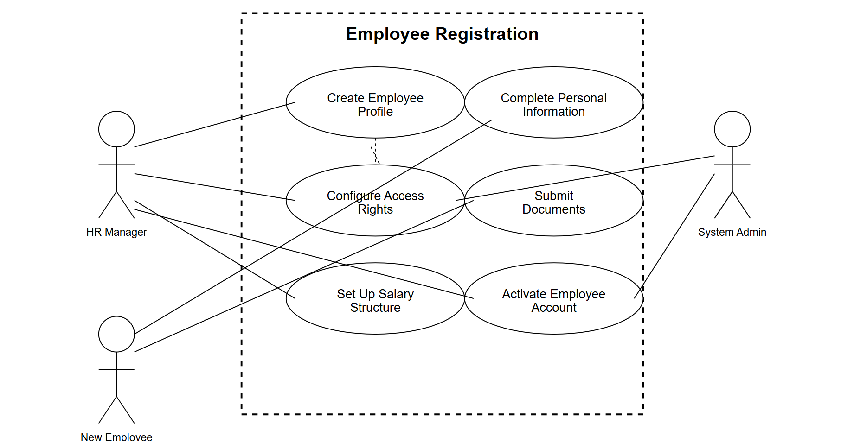

**Payroll Processing Diagram**

**Actors:** Payroll Officer, Finance Manager

**Use Cases:**

1. Calculate Salaries

2. Approve Payroll

3. Disburse Payments

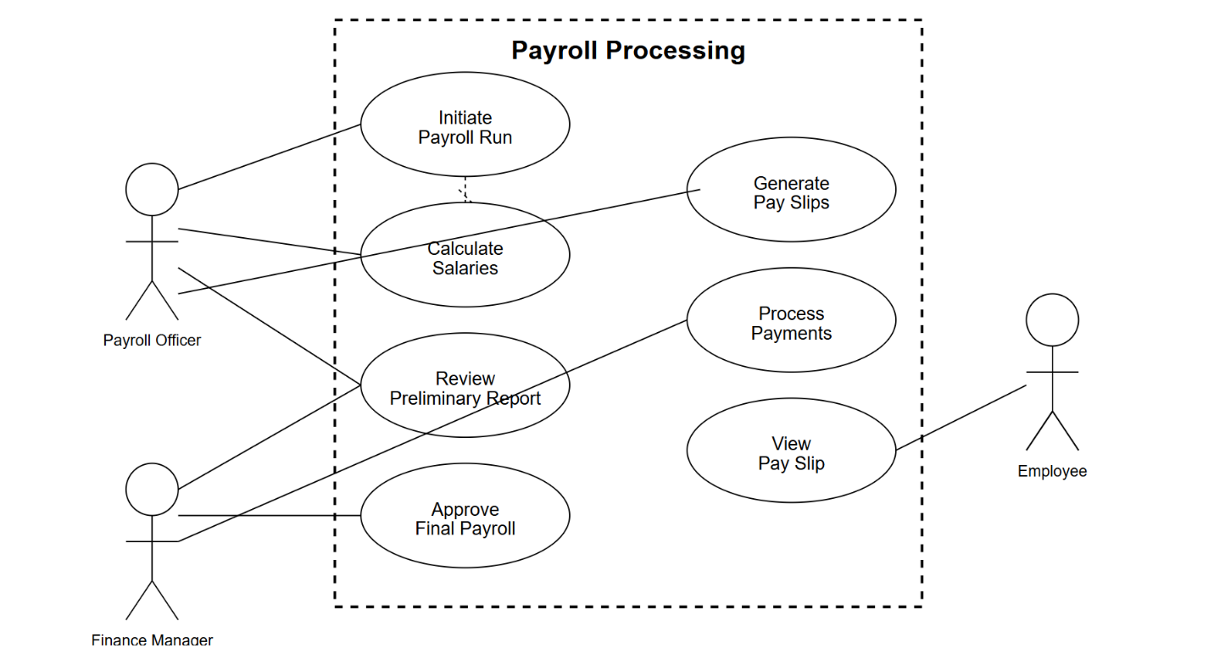

**Claims Management Diagram**

**Actors:** Employee, HR Manager, Finance Manager

**Use Cases:**

1. Submit Expense Claim

2. Upload Supporting Documents

3. Process Reimbursement

4. Track Claim Status

5. Verify Against Policy

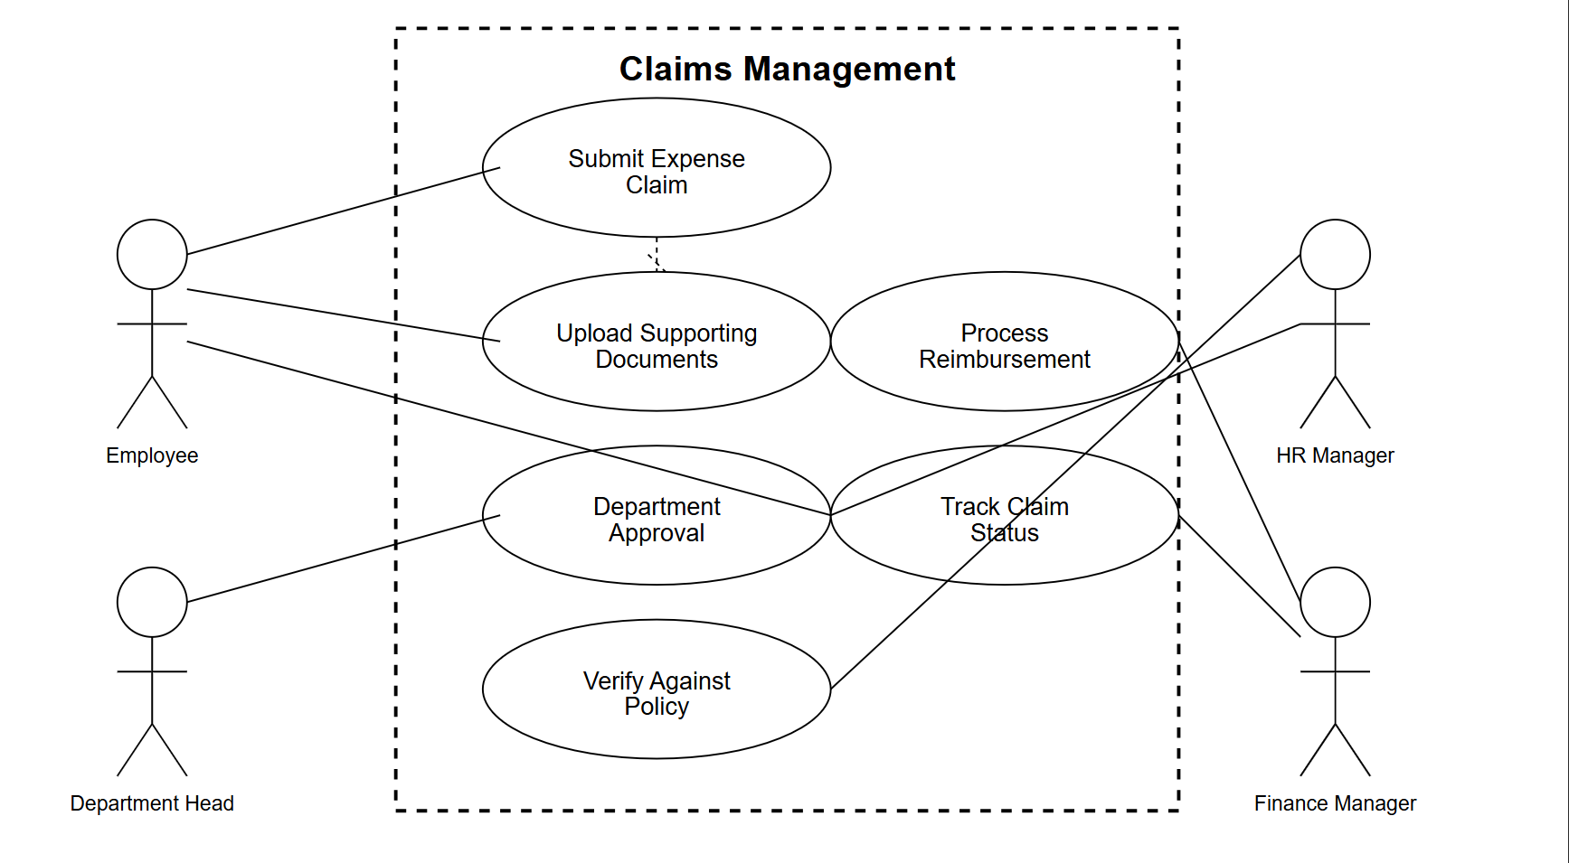

**6. METHODOLOGY**

**System Development Approach**

The development of the Employee Payroll System will utilize an Agile methodology, specifically Extreme Programming (XP), to ensure flexibility and responsiveness to changing business needs. This approach emphasizes iterative development, continuous testing, and rapid feedback, allowing for adaptations throughout the project lifecycle. Key practices include:

* **Pair Programming:** Developers work in pairs to enhance code quality and facilitate knowledge sharing.
* **Automated Testing:** Continuous integration and automated testing ensure the system remains stable and functional as new features are added.
* **Iterative Development:** Features are developed and released in small increments, allowing for ongoing feedback and adaptation.

**Testing Strategy**

* **Unit Testing:** Individual components are tested to ensure they function as expected.
* **Integration Testing:** Ensures that different components work together seamlessly.
* **User Acceptance Testing (UAT):** End-users validate the system against real-world scenarios to ensure it meets their needs and expectations.

**Implementation Plan**

* **Project Initiation:** Define project scope, goals, and timelines.
* **Development Phases:** Implement features iteratively, with regular feedback and testing.
* **Deployment:** Roll out the system to users, providing comprehensive training and support.
* **Post-Deployment Support:** Monitor system performance, address any issues, and plan for future enhancements.

**7. USER GUIDES**

The user guide is designed to provide step-by-step instructions for different user roles interacting with the Employee Payroll System. It ensures that administrators, HR managers, and employees can efficiently utilize the system's features.

**Administrator Guide**

The administrator is responsible for managing the system backend, overseeing payroll operations, and ensuring compliance. Key sections include:

**System Setup:**

* Configure organizational settings such as tax rates, salary structures, and payment methods.
* Integrate external tools like accounting software or biometric attendance systems.

**Employee Management:**

* Add new employees by entering their personal details, salary structure, benefits, and tax information.
* Update or delete employee profiles as needed.

**Payroll Processing:**

* Initiate pay runs and automate salary calculations based on attendance, claims, loans, and deductions.
* Generate payslips and approve payments.

**Reporting:**

* Create detailed reports on payroll summaries, tax deductions, employee attendance, and departmental costs.
* Export reports for compliance or auditing purposes.

**HR Manager Guide**

HR managers oversee employee records and handle approvals for claims, loans, and leave requests. Key sections include:

**Employee Profiles:**

* Access detailed employee records to review salary structures, benefits, and attendance data.
* Update profiles with changes in roles or remuneration.

**Claim & Loan Management:**

* Review submitted claims and loans for approval or rejection.
* Track loan repayment schedules and ensure deductions are accurately reflected in payroll.

**Attendance & Leave Management:**

* Approve or reject leave requests submitted by employees.
* Monitor attendance records to identify patterns or discrepancies.

**Employee Guide**

Employees interact with the system primarily through the self-service portal to access payroll-related information. Key sections include:

**Dashboard Overview:**

* Navigate the dashboard to view key metrics like attendance records and leave balances.
* Access notifications regarding payroll updates or approvals.

**Payslip Access:**

* View and download payslips securely from the portal.
* Review detailed breakdowns of earnings, deductions, and net pay.

**Claim & Loan Submission:**

* Submit claims (e.g., expense reimbursements) with supporting documents.
* Apply for loans by specifying amounts and repayment terms.

**Leave Requests:**

* Apply for leave directly through the system.
* Track approval status and remaining leave balances.

**Features Common Across Guides**

* **Help Section:** Each user role has access to a help section with FAQs and troubleshooting tips for common issues.
* **Notifications:** Real-time notifications alert users about pending tasks (e.g., approvals or submissions).
* **Data Security:** All users interact with encrypted data to ensure confidentiality of sensitive information.

**8. APPENDICES**

The appendix section provides supplementary information to support the main body of the proposal. It includes definitions, FAQs, references, and other resources to enhance understanding and usability of the Employee Payroll System.

**Appendix A: Glossary**

A comprehensive glossary of terms used in the system to ensure clarity for all users:

* **Payroll:** The process of calculating and distributing employee wages and salaries.
* **Deduction:** Amounts subtracted from an employee’s gross pay (e.g., taxes, loans).
* **Net Pay:** The final amount paid to an employee after all deductions.
* **Claim:** A request for reimbursement or compensation submitted by employees.
* **API (Application Programming Interface):** A set of protocols for integrating external systems like accounting software.

**Appendix B:** Frequently Asked Questions (FAQ)

* Answers to common questions about the system:
* How is attendance data integrated?
* Attendance data is collected through biometric devices or manual inputs and automatically synced with payroll calculations.
* Can employees access their pay slips online?
* Yes, employees can securely view and download their pay slips via the self-service portal.
* What happens if there is a discrepancy in payroll calculations?
* Administrators can use built-in audit tools to identify and resolve discrepancies before finalizing payroll.

**Appendix C:** Referenced Documents

* A list of documents referenced during system development:
* Organizational HR policies on claims, loans, and leave management.

**Appendix D:** Support Contacts

Details on how users can access support for technical issues:

**Email Support:** employeepayrollsystem@gmail.com

**Phone Support:** +233 543785321(Available 24/7)

**GITHUB LINK**

<https://github.com/dopponghacker/Employee-Payroll-System.git>

**GROUP SIX (6) MEMBERS**

1. OPPONG DOMINIC UEB3246522
2. AHMED IBRAHIM UEB3246422
3. AMPOFO GEORGE ADINKRA UEB3245322
4. ADU CHRISTABEL GYAMFI UEB3245422
5. AMO MENSAH SAMUEL UEB3245222
6. GYASI KINGSLEY WIREDU UEB3245722
7. OPOKU EMMANUEL UEB3245822
8. OTENG FRANCIS KOFI UEB3246022
9. ABDUL-RAZAK RAHEEM UEB3246222
10. OWUSU ELIZABETH UEB3235122
11. BAYUGO AHMED LATIFATU UEB3237122